Many people have trouble with online dating apps, but I've had great success on this one lowkey website: Ashley Madison

* Language is so abstract and ambiguous

*"Dating"*

*"Relationship"*

*"Cheating"*

Everyone and their mother has a different interpretation when using the above words. This leads to miscommunication and misunderstandings. High level words are good for the average person who hasn't explored themselves or assumes the orthodox culturally common definition of these terms that is shown in movies and media.

But for everyone else, the devil is in the details. Everything is a spectrum.

* Red Flags

*"When you look at someone with rose-colored glasses, all the flags just look like flags."*

Whether they're called red flags or green flags, I only really have a few deal breakers. I need someone open minded because I think that's a core part of who I am. I'll always enjoy learning new things and teaching/talking/sharing what I'm experienced in.

I also envision my best life as a social one. Someone who loves people and is always open to meeting and hanging out with strangers or friends. A core value is being kind and caring about others -- this primarily manifests in how people treat strangers, especially those who are less desirable (wait staff, homeless, physically disabled, intellectually disabled, socially awkward, etc).

* Cheating

*"Monogamy used to be one person for life. Monogamy today is one person at a time"*

*"I am monogamous in all my relationships."*

There's a million and one things to write in this section so I'll freeform bullet points :

- We turn to one person to fulfill a long list of needs : greatest lover, best friend, best parent, trusted confidant, emotional companion, intellectual equal, financial advisor, the list goes on.

And I am it : I'm chosen, unique, indispensable, irreplaceable. I'm the one.

- In the quest to define cheating given the continuously expanding list of activities – sexting, porn, dating apps, VR, etc. I've done it – the abstraction of cheating is simply breaking expectations. With higher resolution relationships, cheating is more robust but until then it's very abstraction and lowest common denominator.

- Cheating as an unexpected betrayal is especially deconstructing because it dismantles all foundations. The first being knowing the other people. The second being knowing who we are as a couple. And lastly, knowing who you are and whether your judgment is sane. Once the foundation of yourself is shaken, it is common to spiral into second-guessing everything else.

* Linearity

I've had this article in the writing for a good year and since the beginning I've changed. I no longer believe in right answers and linearity. I don't believe there's clear progression or meritocracy or that thinking deeper is helping me.

Confidence

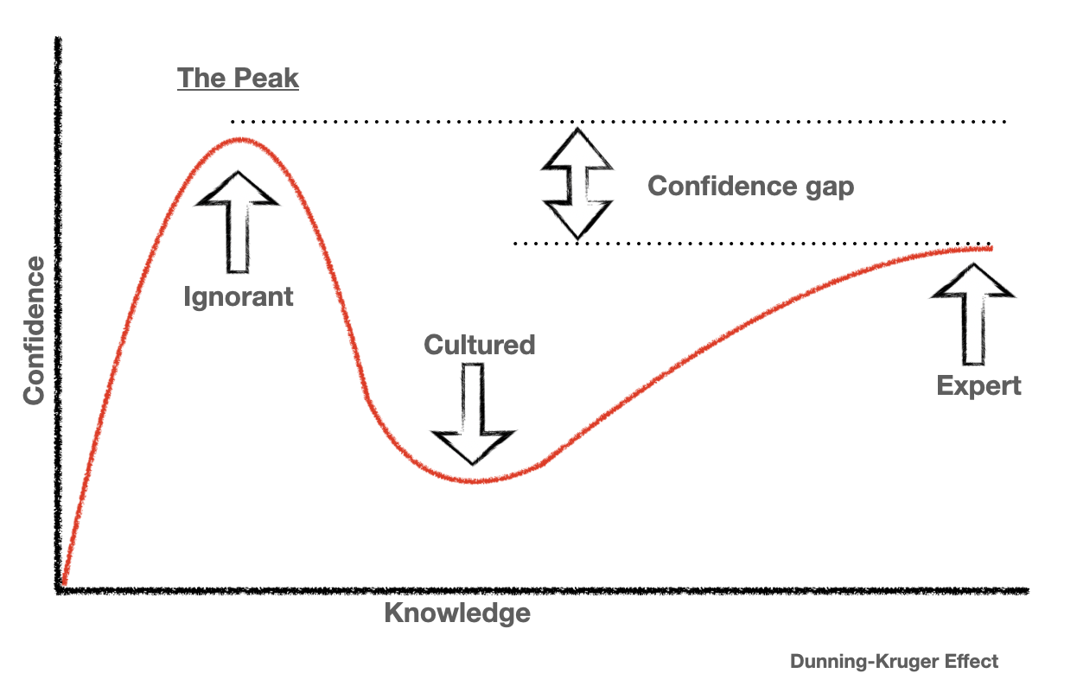

I fundamentally believe that most people do not know what they want – or rather what they actually want.

They have a conceptualization of what they desire and what works for them – based on the premise of a conceptualization of *who they are*.

Almost always, they are incorrect. Or rather, they are not wholly correct. Or rather, it's also a dynamic problem so inevitably they will be incorrect – always. When you take away things, people are incredibly resilient and homogenous. Things are just fine – and often good, without fitting all the pieces of the puzzle exactly in the right way. Chances are you went to school in a classroom with 30 random people, and chances are you did fine – you had a group of friends, you had a best friend. It worked out.

Chances are you got a job with a company and there were 20 or so coworkers. And you got along and are somewhat friends with them.

Certainly, a relationship is more than coworker friendship, but the underlying principle is that there is plenty of sufficiency on average with most people.

Note to self: be charitable and enjoy relationships. Love and certainly attraction manfiest in many more forms. The ones closest to us are likely not the ideal form and have flaw that we would not choose for ourselves but we love and they fulfill X needs all the same.

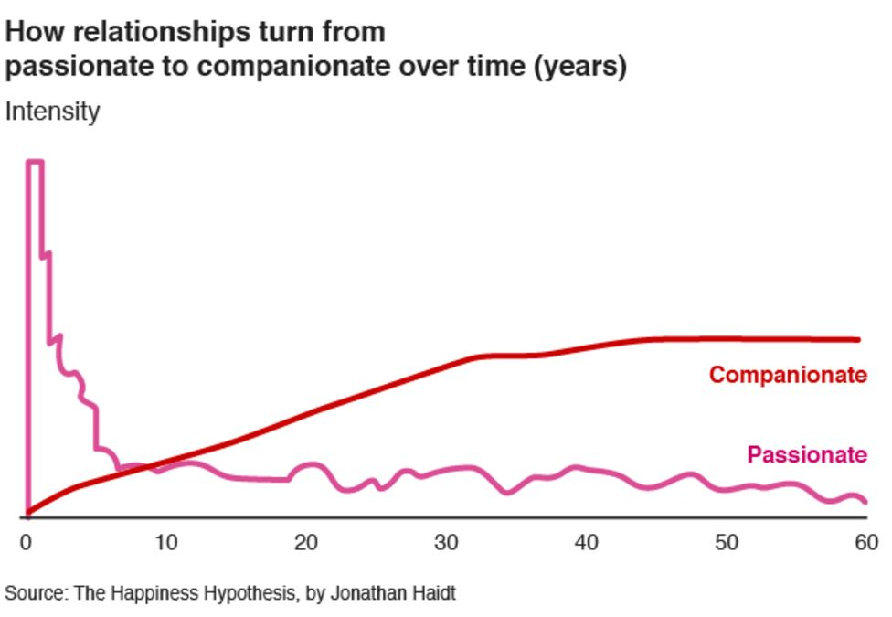

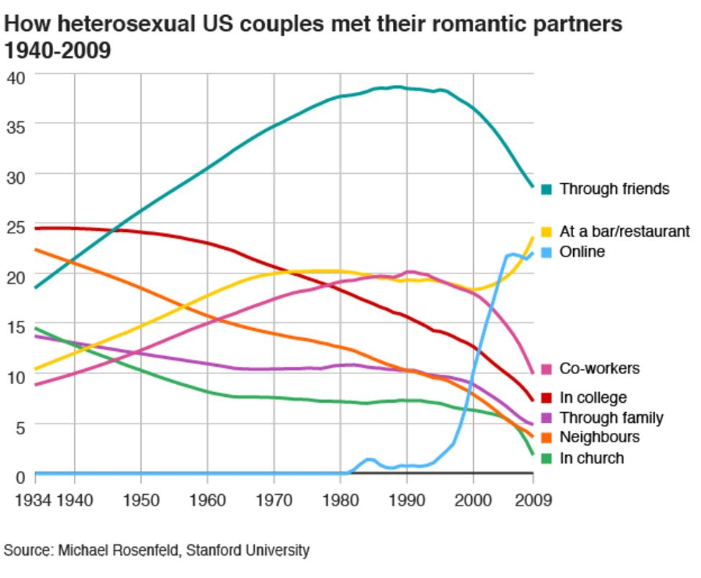

I believe in the paradox of knowledge, and that's the most damning thing.

The more qualified one is, the less likely they are to get the position.

The more accurate a high-resolution understanding, the less likely to succeed tangibly.

The more one knows themselves, the more disqualified they are to find someone for themselves.

The hardest part is everyone is multi-faceted at different times, at different rates. Perhaps the only constant predictable thing is where you want to go and one's values, but of course even those are subject to change.

We all want someone fun, yet serious at the right moments. Courageous in that they aren't too reckless, but also not too cowardly. Intelligent but also hilarious, active but also homely.

You want them to want you, but only as much as you want them. Too much and it's overbearing, too little and you're left yearning.

Casualty in the short term but a life partner in the end game. Low standards for dating yet absurd standards for marriage and exclusivity.

Less definitions and rigidity and focus is likely better for me, as in better results. It's like the person who has selection bias and they repeatedly like a terrible type of person, that pattern of not being able to trust one's feelings and override them with past history and friend discernment.

.

At a previous time divorce was a failure. However in the modern era staying when one can leave is the new failure.

At a previous time divorce was for unhappiness. In the modern time one divorces to be happier.

This most certainly is poorly written and only scratching the surface. There are so many complex ideas, hopefully in a future article they'll be communicated and laid out properly.

The more drunk one is, the more utilitarian

<https://www.youtube.com/watch?v=5fQrQbtS5lU>

Kilo Kish & Miguel - Death Fantasy